# Reporting Tool

# TBL_REPORTS

1. **NAME** (VARCHAR): Report name to be displayed in drop down list.

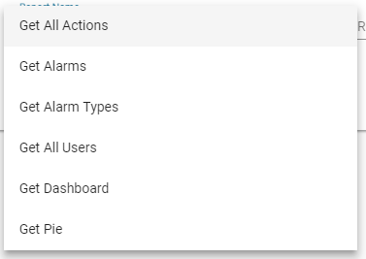

1. **PROC_NAME** (LONGTEXT): Query to be initialized to get report data. In case a report can be a chart the first column will be the x-axis and the other columns are the y-axis. Example “Select * from table where msisdn ? and name ?”
2. **LAST_QUERY_CONTAINS_WHERE** (1 or 0): this field should be 0 in case root query contains where and 1 in case root query did not contains where.
3. **LAST _ QUERY _ CONTAINS _ORDER** (1 or 0): this field should be 0 in case root query contains order by and 1 in case root query did not contains order by.
4. **LAST _ QUERY _ CONTAINS _GROUP** (1 or 0): this field should be 0 in case root query contains group by and 1 in case root query did not contains group by.
5. **CHART_TITLE** (VARCHAR): these field is null in case report style is a table and not null in case of chart.
6. **CHART _SUBTITLE** (VARCHAR): these field is null in case report style is a table and not null in case of chart.



# TBL_REPORTS_FILTER

1. **REPORT_FIELD** (VARCHAR): field name to search by in our query (should be the same as field name in query).
2. **FIELD_TYPE** (NUMBER, TEXT or DROPDOWN): field type to be displayed for user to search.
3. **REPORT_ID** (INT): related report id.
4. **DISPLAY_NAME** (VARCHAR): displayed name for user in placeholder.
5. **SELECT_QUERY** (LONGTEXT): field is null in case “NUMBER” or “TEXT”. This field should contains the select query to be placed in our drop down list. Please note that this query should return two column only the first column should be renamed to “relatedField” and the second one should be renamed to “value”. Example: SELECT id as relatedField, name as value FROM users.

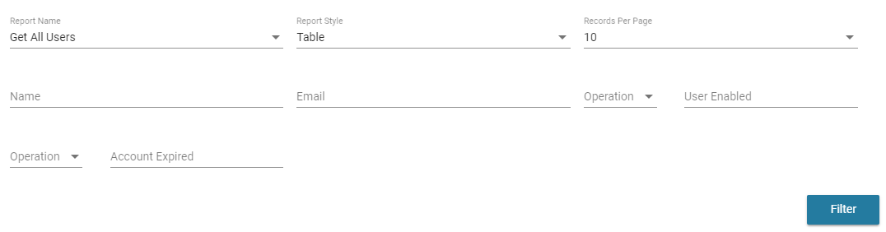

1. **FIELD_INDEX** (VARCHAR): field index in main query to be replaced by search query. Example “Select * from table where msisdn ? and name ? and msisdn ?”. in this case msisdn index filter is 1 and 3 and name index filter is 2 so msisdn fiel_index should be as follow (1,3).
2. **Reuired** (1 or 0): this field should be 1 in case search is required for specific database field and 0 in case not.

TBL_REPORTS_STYLE

This table contains predefined report style that can be joined with reports in TBL_REPORTS_STYLE_JOIN.

NOTES

* Export option is available in two options first one in case database is on the same backend server and the second option is in case the database is on another server. In this case we should add four properties to the property file in tomcat work directory (shared.mysql.username, shared.mysql.password, shared.mysql.network_smb_folder, shared.mysql.local_dump_folder) a folder should be shared to get the excel file from. So in this case we should provide the local path and network path for this folder as the below example.

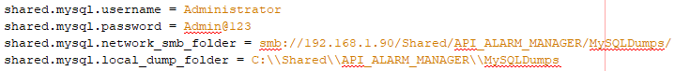Note that in case the database is on the same server we should remove these variables.

* Note that every field in report query should contains “as” and quotes for example: Select name as ‘name’ from tbl_reports.
* All counters in a query shall be casted to “Char” for example: select group_name as 'Group', CAST(count(msisdn) AS CHAR) as 'Number of MSISDN' from tbl_groups.
* Do not add “;” in the query.

NOTES TO BE UPGRADED LATER

Better to set fields that contains drop down in “tbl_reports_filter” at the last. So loading will appear for user while getting drop down data from database.

No validation for user input like numbers.

Add test query option.